Chapter 18, Solution 12.

(a) 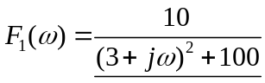

(b) 